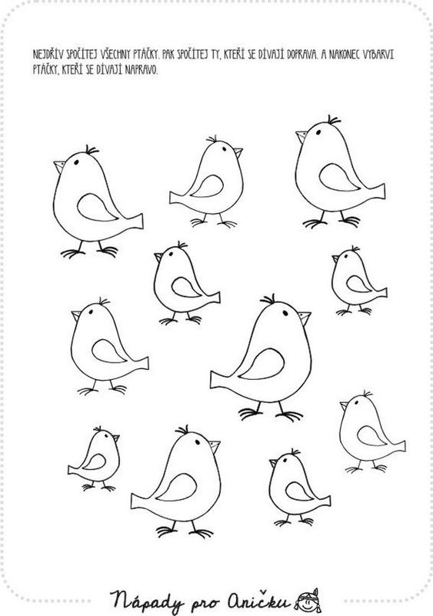
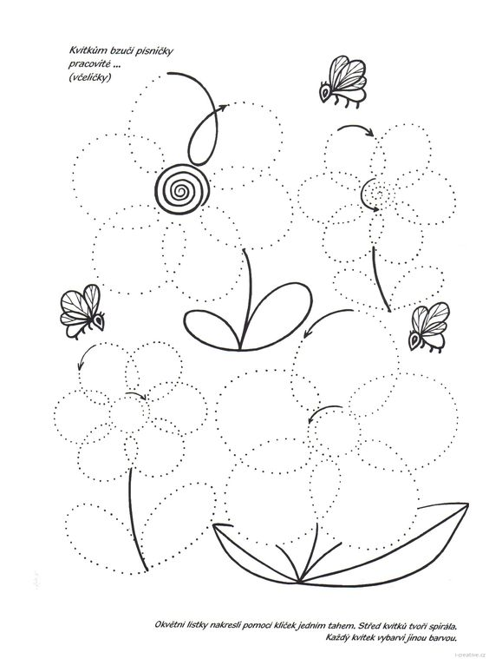
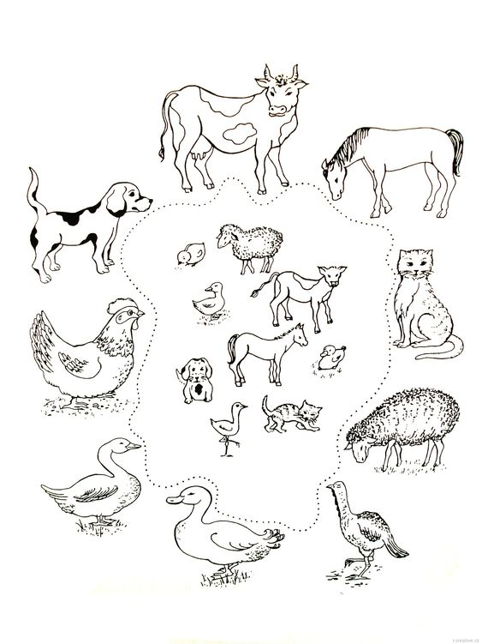
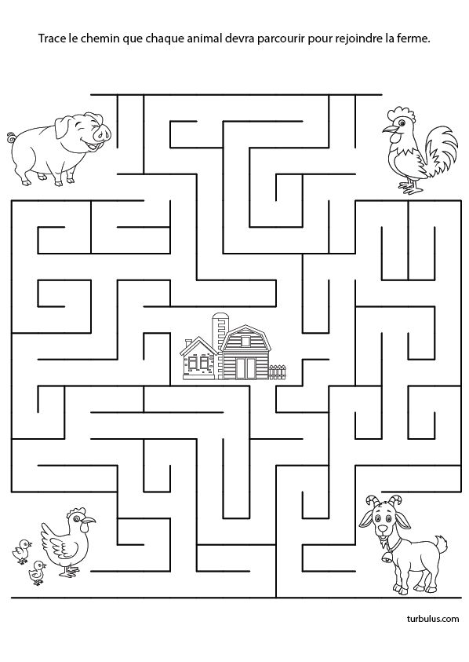
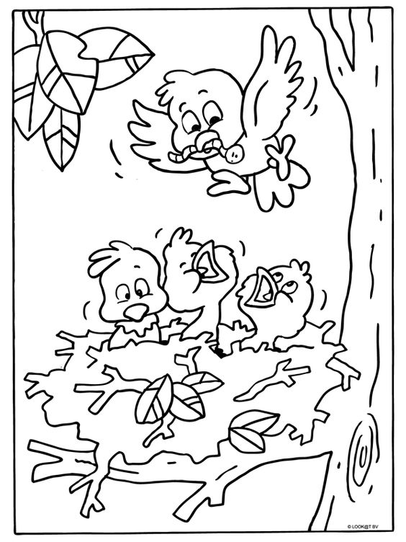
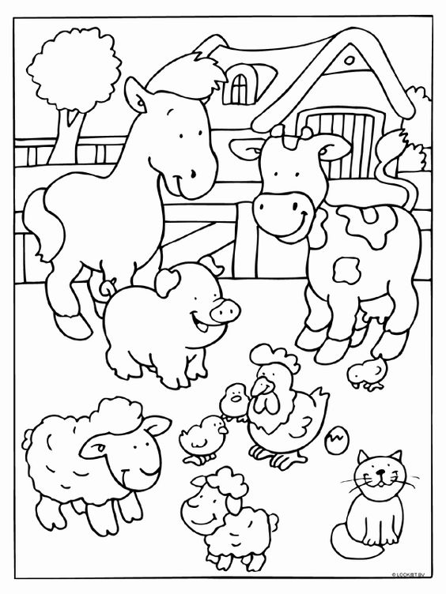
Zdroj
- https://www.i-creative.cz/2013/05/02/jarni-pracovni-a-grafomotoricke-listy/
- http://www.napadyproanicku.cz/pracovni-listy-a-sablony/pracovni-listy
- https://www.i-creative.cz/2012/04/03/zvirata-a-jejich-mladata/
- http://ideas.petsecret.net/espace-trace-le-chemin-que-chaque-animal-devra-parcourir-pour-rejoindre-la-fer/
- https://coloringhome.com/coloring-page/7722
- http://www.kleurplaten.nl/vogel/vogels-nestjes-voorjaar-k-9998.html
- https://www.cantikitu.com/

